Biometric Device Integration with Web Application (Easy WDMS)

1. Prerequisites (Before You Start)
Ensure the following items are available:
- ✅ Biometric Device (Easy WDMS supported model)
- ✅ Power Cable
- ✅ LAN (Ethernet) Cable
- ✅ Network Switch / Router
- ✅ Computer / Laptop connected to the same network
- ✅ Easy WDMS Web Application access

2. Hardware Connection (Physical Setup)

Step 1: Power Connection
- Connect the power cable to the biometric device.
- Switch ON the device.
- Wait until the device boots completely.

Step 2: LAN Connection
- Connect one end of the LAN cable to the biometric device.
- Connect the other end to the network switch or router.

3. Device Network Configuration (On Biometric Device)

Step 3: Open Device Menu
- On the biometric device screen, press the Menu button.
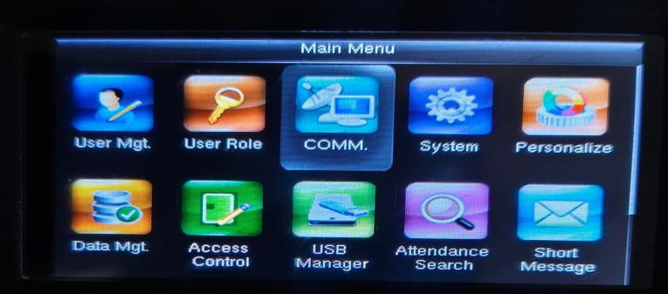

Step 4: Go to Communication (COMM) Settings
- From the Menu list, select COMM (Communication).
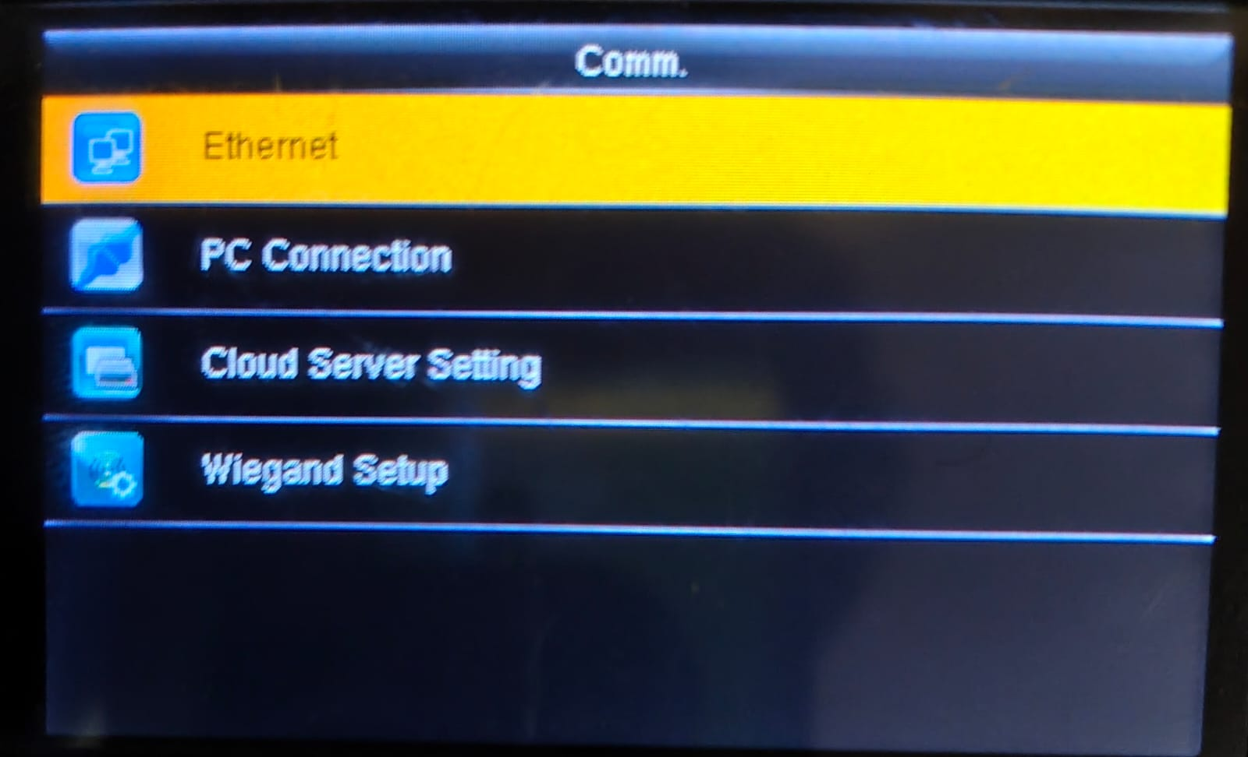

Step 5: Ethernet Settings
- Inside COMM, select Ethernet Settings.
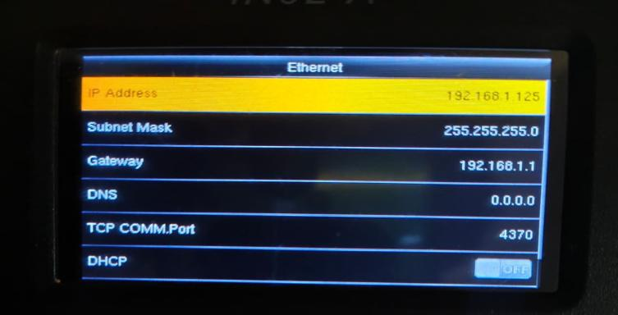
Fill the details as follows:

Ethernet Configuration
- Device IP Address: Set a unique IP (example: 192.168.1.200)
- Gateway: Same network series (example: 192.168.1.1)
- Subnet Mask: 255.255.255.0
Important Rules: - IP, Gateway, and Server must be in the same series. - Do NOT change the subnet mask.

Step 6: Cloud Server Settings
- Go back to COMM menu.
- Select Cloud Server Settings.
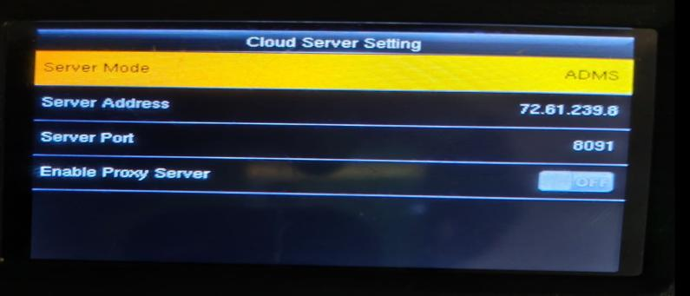
Fill the details:
- Server Address: 72.61.239.8
- Server Port: 8091
- All other fields: Keep unchanged
✅ Save the settings.

4. Easy WDMS Web Application Configuration

Step 7: Open Web Application
- Open a browser (Chrome recommended).
- Enter the URL:
http://72.61.239.8:8091/

Step 8: Login Credentials
Use the following login details:
- Username: admin
- Password: Admin@123
✅ Click Login.

5. Device Registration in Web Application

Step 9: Go to Device Settings
- After login, navigate to:
Settings → Device Settings
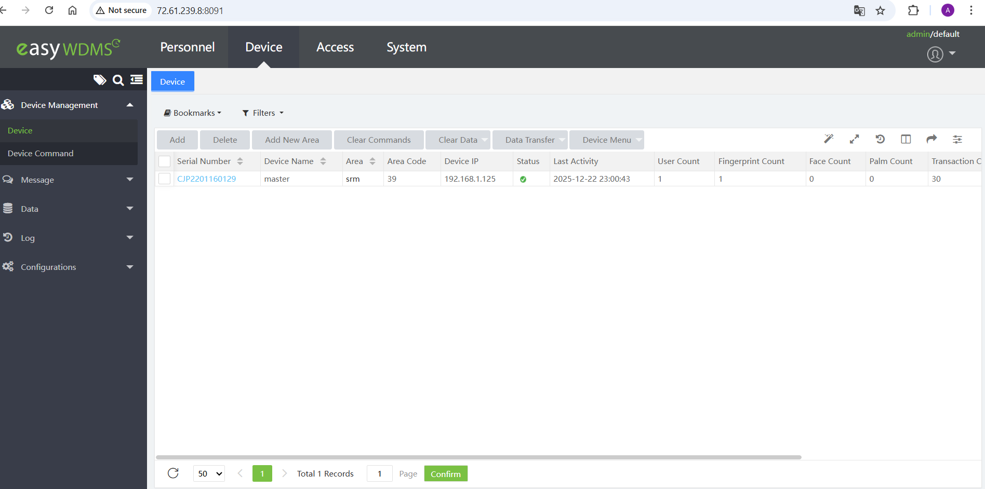

Step 10: Check Existing Device
- If the biometric device is already listed:
  - Verify the status icon is ✔ (Tick Mark).
✅ Tick status means device is connected properly.

Step 11: Add New Device (If Not Listed)
If the device is not available, click Add New Device.
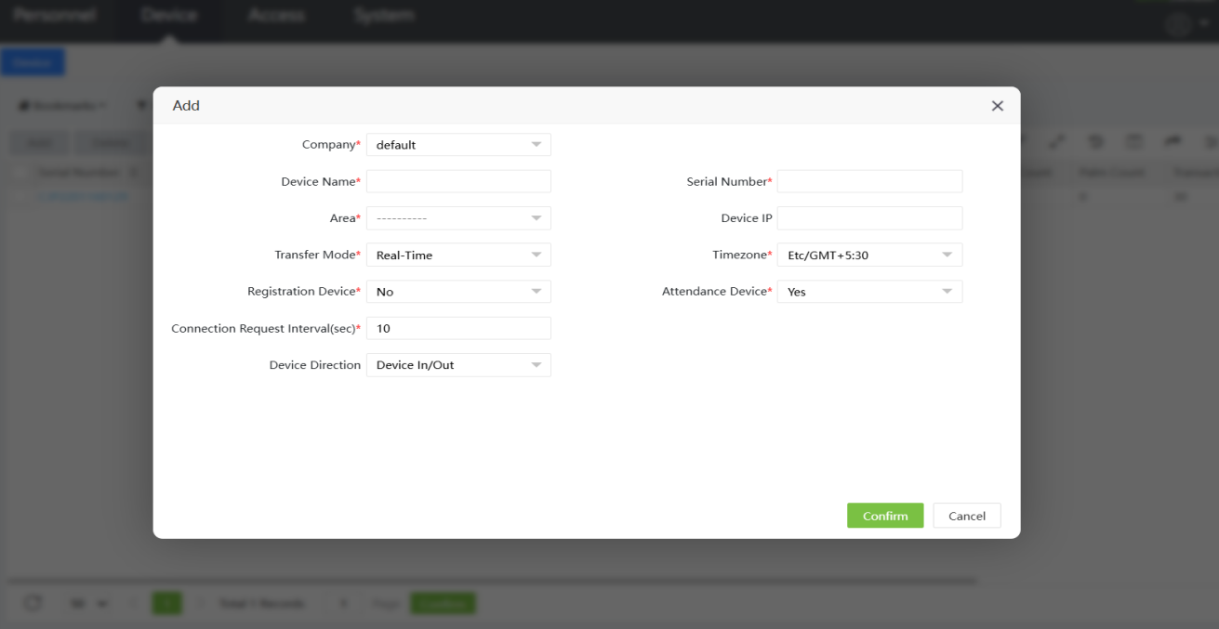
Fill the details:
- Device Name: Any name (example: Main Gate Device)
- Location / Area: Where the device is installed
- Device Serial Number: From device label
- Device IP Address: Same IP configured in device
- Remaining Fields: Keep default / unchanged
Click Submit.

Step 12: Verify Device Status
- After adding, check the device status.
Status | Meaning
✔ Tick | Device connected successfully
❌ Cross | Device not connected

6. Network Testing (If Device Is Not Connected)

Step 13: Ping Test (CMD)
If device status is ❌:
- Open Command Prompt (CMD) on the computer.
- Run the command:
ping <device_ip>
Example:
ping 192.168.1.200

Result Analysis
- ✅ Reply received → Network is OK
- ❌ Request timed out → Check:
  - LAN cable
  - Device IP
  - Server IP & Port
  - Gateway settings

